Introduction
Generally, women are thought to be less violent than men. This reasoning extends to all areas of violent action, including domestic violence, terrorism, and political violence. There has been much research conducted on women as targets of violence and sexism, but less so on the violence committed by women themselves. As political violence increases in America, I believe it vital to analyze what drives people to commit such extreme crimes; women are no exception to this. However, in order to analyze this phenomenon, we must first ask what types of political crimes are women committing and when are they committing them? In this paper, I ask a causal question: does gender influence the form of political violence committed?
With the data, I examined violent and nonviolent crimes committed by men and women. I first looked at a more comprehensive set of cases from between 1990 – 2025 and later narrowed the data to only presidential election years from 1992 – 2024. I hypothesized that women would commit less crimes overall, with a tendency toward committing crimes classified as nonviolent. My results confirmed this hypothesis, while also offering some insights into crimes committed by men. However, the relationship between political violence and presidential election years was not as clear.
Background
Political violence is not a new phenomenon within the United States. However, the nature of attacks and radicalization has been changing in recent years due to the internet, social media, and growing political polarization. After large, media-covered incidents, like the attack on the U.S. Capitol and the assassination of Charlie Kirk, the majority of Americans believe that “politically motivated violence” and extremism is increasing on both the left and the right (Copeland and Kiley). Support for violence, while still relatively low, has notably also been increasing on a bipartisan level, with “Republicans and Democrats […] espousing similar views on the acceptability of violence since 2017” (Kleinfeld 167). As political violence permeates popular American thought across the parties, it is important to explore all possible sources of violence in the country.
Women are a demographic often overlooked in the causation of political violence. This is likely due to their being perceived as more peaceful or less aggressive than men. Women’s participation in violence is frequently thought of or portrayed as “unnatural, gender defiant, sexually deviant, psychologically unstable, or easily manipulated” (Sjoberg et al. 2). However, to blindly follow traditional gender assumptions in relation to political violence ignores a very real group of women who do participate in terrorism and violent crime. With political polarization and extremism escalating, especially amongst those who “feel particularly aggrieved towards women,” I believe it equally important to examine how women respond to or create violence themselves (Kleinfeld 162). Further, gender norms also provide a potential cover for future violence, as it could mislead preemptive efforts to stop crime into discounting women as agents of attacks. In the interest of U.S. security, a gendered analysis of political violence is needed.
I look at if gender influences the form of political violence committed, specifically between crimes classified as violent and nonviolent. Although I predict women to commit less crime than men, I predict that violence among women to have increased in recent years. Further, women may have a greater tendency to commit nonviolent crimes. I additionally predict for violent crime in women to increase during presidential election years, due to the high political tension during these times. Lastly, I hypothesize that violence between both genders increased during 2019 and 2020. This increase may be related to factors like “Trump’s first impeachment, when Republican support for violence spiked” and the “inequality and loneliness” exacerbated by the COVID-19 pandemic (Kleinfeld 166).
Data and Approach
Using data provided by The Prosecution Project (tPP), I examine correlations between gender and types of political crimes. This base dataset is an ongoing project tracking crimes tied to political felony criminal cases in the United States from 1990 to the present. It includes a variety of demographic variables, like gender, and facts about the cases, like methods. There are 5405 rows in the dataset, with each row representing an individual criminal defendant. There are 47 columns representing the different descriptive variables. It should be noted that although data includes cases from 2025, the most recent year is typically not representative or immediately updated; “a case will not be fully coded until the defendant is sentenced, (“The Prosecution Project”).
The variables I primarily used were Gender, Year, and Violence type. Due to the lack of significant data on gender non-conforming persons (only 14 cases), I limited the Gender variable to only those who identify as male or female. Gender is the independent variable/grouping variable, while the type of violence committed is the outcome that changes dependent on the grouping. I look at how the relation between gender and the type of violence changes between 1990-2025, and more specifically at the presidential election years during that period (1992, 1996, 2000, 2004, 2008, 2012, 2016, 2020, 2024). I reformatted the date column into a new, year-only column for ease of comparison.
For violence type, I differentiate between violent and nonviolent crimes, adhering to the Federal Bureau of Investigation’s definition of violent crime in the Uniform Crime Reporting Program. I created a new column in the tPP data to represent the violence type of each case. Violent crime consists of the following criminal methods: Armed intimidation/standoff, Chemical or biological weapon deployment, Explosives, Firearms: civilian, Firearms: military, Hostage-taking, Unarmed assault, Vehicle ramming, Arson, and Other weapons. Meanwhile, nonviolent crime consists of the following: Blockading/unlawful assembly, Perjury/obstruction of justice, Providing material support, and Threat/Harassment.
I compare the general numbers of male and females who commit violent and nonviolent crimes using bar plots, and then compare these numbers over time, using line plots. I made multiple plots to look at the genders individually and to directly compare them together. I based the models off Problem #1 and #3 of Problem Set 3 in the course materials. Additionally, I created a subset of the tPP data to analyze the data from the election years specifically. I believe this is a suitable approach for a clear comparison between the two groups. It also provides an emphasis of the differences in female crime in particular. The temporal aspect will help identify patterns or recent developments that may be useful in analyzing and forming interventions for the contemporary state of political violence.
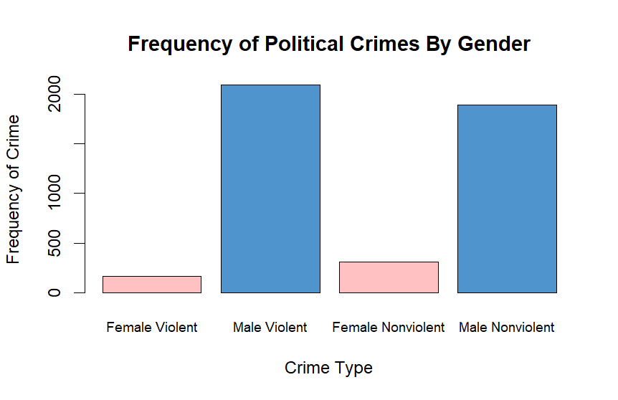
Results
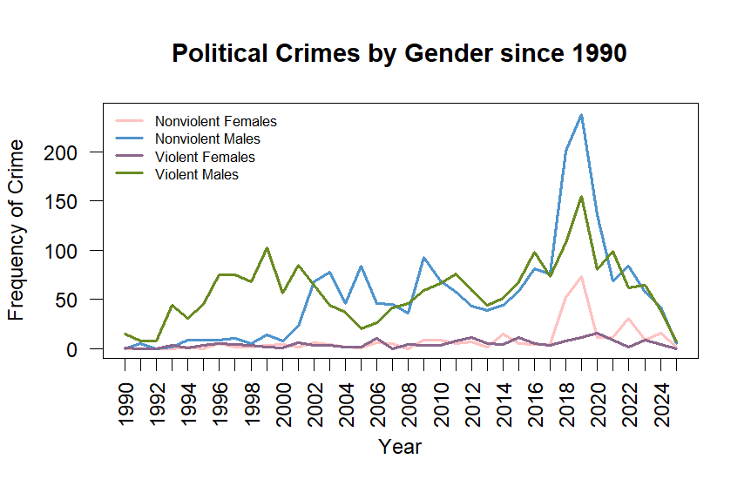
I compared the general frequency of politically motivated violent and nonviolent crimes between female and male criminal defendants. Since 1990, females have committed 165 violent crimes or about 7% of all violent crime, and 308 nonviolent crimes or about 14% of all nonviolent crime. Men, on the other hand, committed more violent than nonviolent crimes. Males committed 2098 violent crimes or about 93% of all violent crime, and 1889 nonviolent crimes or about 86% of all nonviolent crime. These results are consistent with my hypothesis that women will commit less crime overall and have a tendency toward nonviolent crime. It is interesting to note that men tended to the opposite, committing more violent than nonviolent crimes.
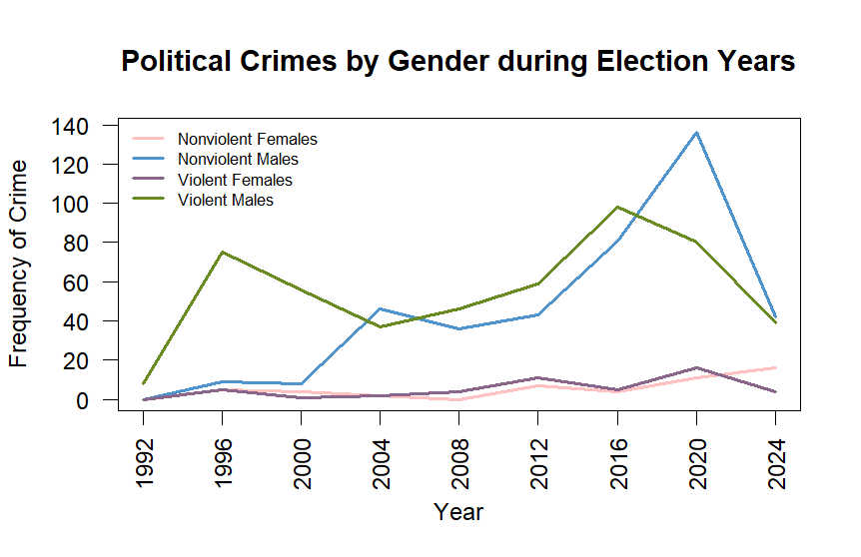
I then compared these frequencies over time, with a more comprehensive look since 1990 and a more specific examination of only presidential election years. Political crimes, since 1990, do not seem to be extremely increasing any longer. However, it was increasing between 2017 – 2019 for nonviolent females, nonviolent males, and violent males. Nonviolent crime has been occurring more than violent crime, for both females and males. Nonviolent crime peaked for both genders in 2019, with 73 cases for females and 238 cases for males. However, these numbers fell to 11 and 136, respectively, in 2020. Violent crime for men also peaked in 2019, with 155 cases, but fell to 80 cases in 2020. The 2019 spike was as expected and may be related to the increased right-wing support for violence at the time (Kleinfeld 166). The 2020 drop may be due to the widespread isolationism of the pandemic. Women, however, committed 11 violent crimes in 2019, but increased to 16 violent cases in 2020. COVID-19 would also account for the spike in female violence, as many women experienced additional stress from added responsibilities in the home.
These results are somewhat in line with my prediction for increased violence in 2019 and 2020, but I did not anticipate nonviolent crime to be generally higher than violent crime in 2019. Also, with the exception of nonviolent female crime, violent females, violent males, and nonviolent males all had higher crime rates in 2018 than they did in 2020. This may be due to the influence of pandemic quarantining and social distancing practices in 2020. Additionally, there does not appear to be a correlation between presidential election years and increased violence in women. However, between 2017 and 2025, nonviolent female crime has been consistently higher than violent female crime, with the exception of 2020. Yet, there is also no general trend of increasing nonviolent crime during presidential election years.
Conclusion
I have found confirmation that gender does influence the form of political violence committed. Overall, women commit fewer political crimes than men and are more likely to engage in nonviolent than violent crimes, aligning with my expectations. Men, on the other hand, are more likely to commit violent than nonviolent crimes. Despite committing less political violence, the data demonstrates that women do participate in political crimes. Female political crime has increased during certain years, like 2019 and 2020, suggesting influence from larger political and social conditions, like COVID-19 and political polarization, even if there is no correlation with presidential election years. These findings are important because overlooking women as potential agents of political violence weakens prevention efforts and leaves a gap in U.S. security measures. Nevertheless, my results are limited by the unrepresentative nature of the recent data. Future research could better analyze possible patterns in the 2020s once the tPP gains a more complete collection of criminal records.
Appendix
Name | Description
Gender | Gender of the criminal; Male or Female
Year | Year of the crime; 1990 – 2025
Violence | Classification of the crime; Violent or Nonviolent
Variables:

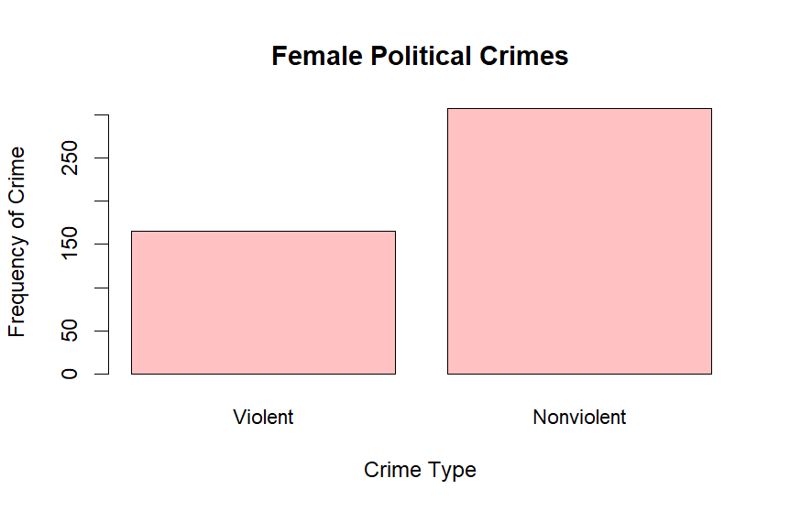

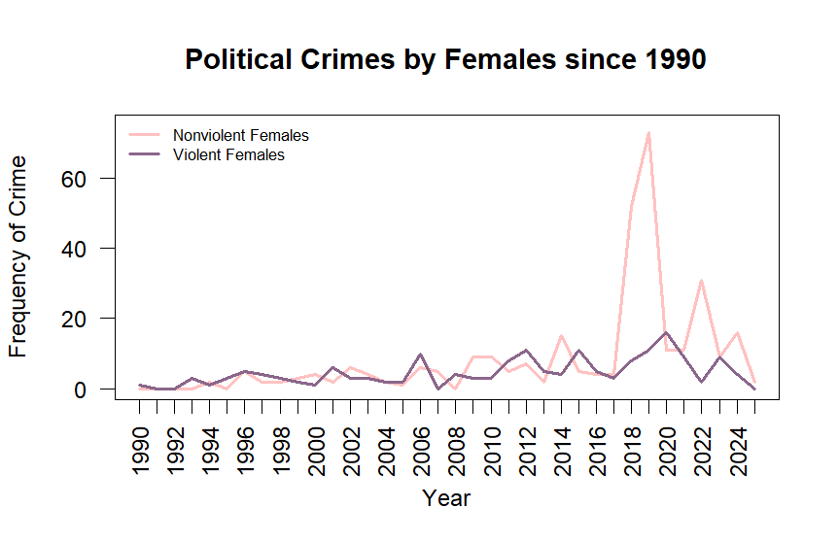

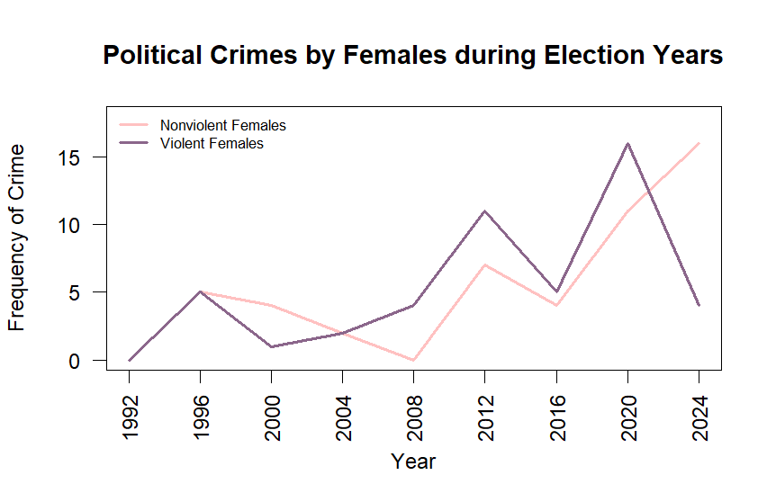

Github: https://github.com/ktwaskas/Differences-in-Political-Crimes-Between-Genders.git

Works Cited
Copeland, Joseph, and Jocelyn Kiley. Americans Say Politically Motivated Violence Is Increasing, and They See Many Reasons Why. Pew Research Center, 23 Oct. 2025, https://www.pewresearch.org/short-reads/2025/10/23/americans-say-politically-motivated-violence-is-increasing-and-they-see-many-reasons-why/.
Kleinfeld, Rachel. “The Rise of Political Violence in the United States.” Journal of Democracy, vol. 32, Jan. 2021, pp. 160–76, https://doi.org/10.1353/jod.2021.0059.
Sjoberg, Laura, et al. “Women, Gender, and Terrorism.” Women, Gender, and Terrorism, University of Georgia Press, 2011, JSTOR, https://doi.org/10.2307/j.ctt46nnjp.
“The Prosecution Project.” 2025, https://data.theprosecutionproject.org/?tab=General&currentPage=1&numShown=10.

